Requirement Analysis
Technology Stack (Architecture & Stack)
Date | 17 February 2026
Team ID | LTVIP2026TMIDS37778
Project Name | Laptop Request Catalog Item

Technical Architecture:

The technical architecture for the Laptop Request Catalog Item in ServiceNow is designed to provide a scalable, modular, and user-friendly solution for employees, managers, and IT administrators. The architecture integrates ServiceNow’s Service Catalog, UI Policies, UI Actions, Approval Workflows, and Update Sets, ensuring efficient request handling, dynamic form behavior, secure access, and cross-instance deployment. This architecture supports streamlined request submission, automated approvals, tracking, and fulfillment while maintaining governance and auditability.

Architecture Diagram:
ER-Diagram:

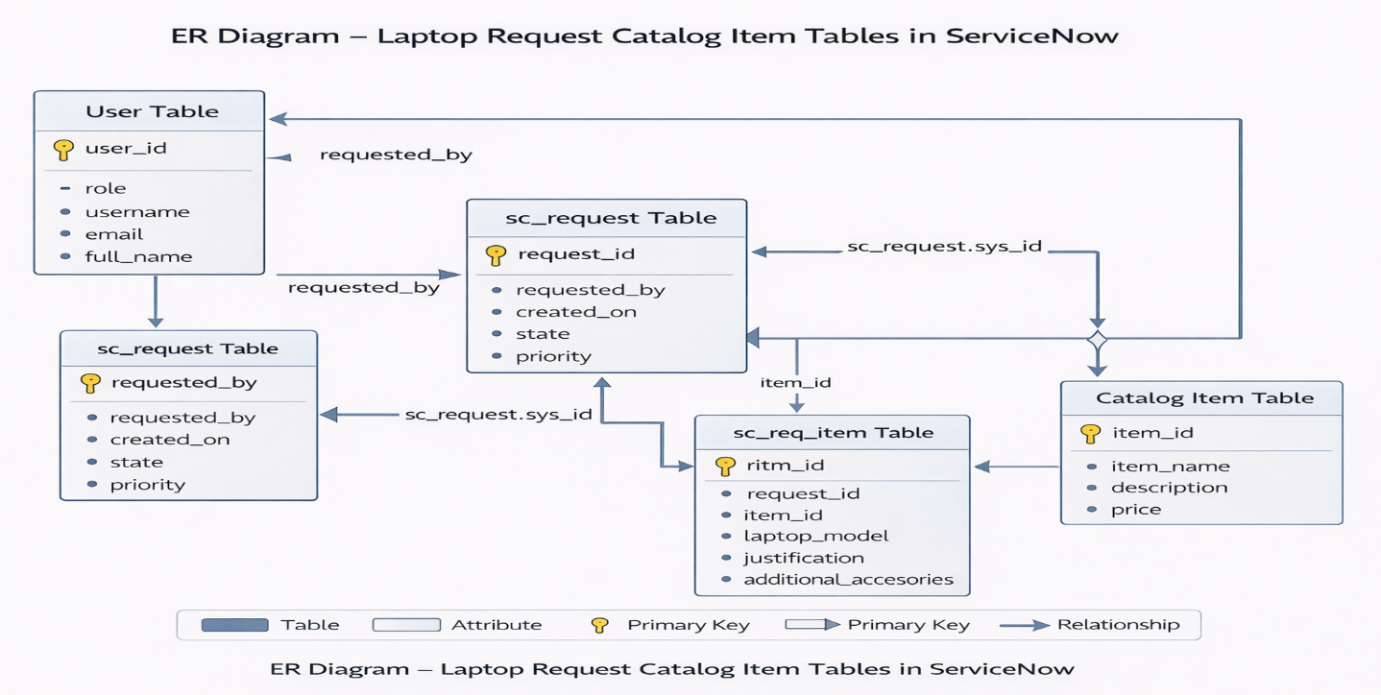
Technical Architecture:

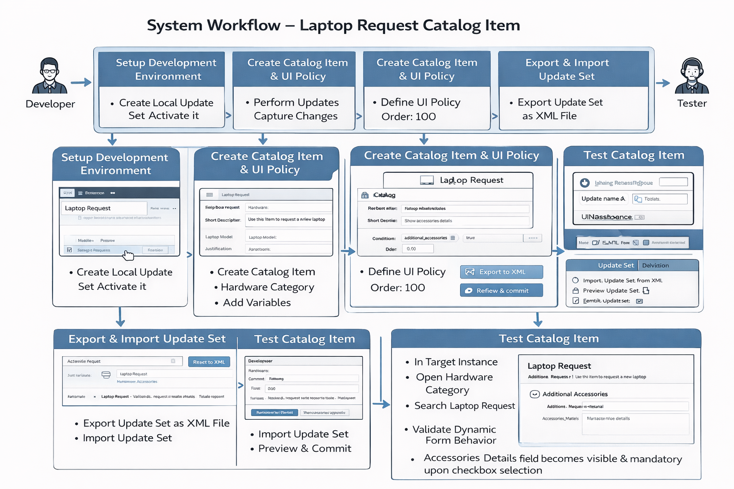

Table-1: Components & Technologies

S.No | Component | Description | Technology
1 | User Interface | Forms and catalog item submission pages for employees, managers, and admins | ServiceNow Service Catalog, UI Forms
2 | Application Logic-1 | Employee request submission, Manager approval, IT fulfillment workflows | ServiceNow Workflow Engine, Business Rules, Flow Designer
3 | Application Logic-2 | UI Policy logic for dynamic field visibility and mandatory conditions | ServiceNow Catalog UI Policies & Client Scripts
4 | Application Logic-3 | Reset form functionality | ServiceNow UI Action (Client Script)
5 | Database | Persistent storage for requests, catalog items, users | ServiceNow Tables (sc_request, sc_req_item, sys_user, catalog_item)
6 | Cross-Instance Deployment | Export and import of update sets | ServiceNow Update Sets (XML Export/Import)
7 | Notifications | Email alerts for request submission, approval, and fulfillment | ServiceNow Notification Engine
8 | Infrastructure | ServiceNow Cloud Instance | ServiceNow Platform (Zurich version)

Table-2: Application Characteristics
S.No | Characteristics | Description | Technology
1 | Platform | ServiceNow Cloud-based ITSM platform | ServiceNow (Zurich)
2 | Security | Role-based access for Employees, Managers, Admins; form field validations | Access Control Rules, UI Policies
3 | Dynamic Forms | Conditional fields and mandatory logic based on user selection | Catalog UI Policies, Client Scripts
4 | Scalability | Modular architecture allows addition of new catalog items and workflows | ServiceNow Platform, Update Sets
5 | Availability | 24/7 access within organization | ServiceNow Cloud, High Availability
6 | Performance | Quick form submission, real-time request updates, email notifications | ServiceNow Workflow Engine, Notifications
7 | Audit & Governance | Track all changes for compliance and cross-instance deployment | Update Sets, System Logs

